Five Little Teddy Bears Nursery Rhyme
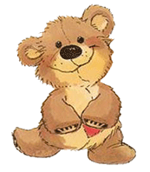
"Five little teddy bears jumping on the bed
One fell off and bumped his head
Momma called the doctor and the doctor said
No more teddy bears jumping on the bed!

Four little teddy bears jumping on the bed
One fell off and bumped his head
Momma called the doctor and the doctor said
No more teddy bears jumping on the bed!

Three little teddy bears jumping on the bed
One fell off and bumped his head
Momma called the doctor and the doctor said
No more teddy bears jumping on the bed!

Two little teddy bears jumping on the bed
One fell off and bumped his head
Momma called the doctor and the doctor said
No more teddy bears jumping on the bed!

One little teddy bear jumping on the bed
One fell off and bumped his head
Momma called the doctor and the doctor said
Put those teddy bears right to bed
*****
One little, two little, three little teddy bears
Four little, five little, six little teddy bears
Seven little, eight little, nine little teddy bears
Ten little teddy bears
*****

Teddy Bear, Teddy Bear, Look around.
Teddy Bear, Teddy Bear,Touch the ground.
Teddy Bear, Teddy Bear, Switch off the light.
Teddy Bear, Teddy Bear, Say “Good night”
******.
Teddy Bear's Picnic Song
If you go out in the woods today
You're sure of a big surprise.
If you go out in the woods today
You'd better go in disguise.
For every bear that ever there was
Will gather there for certain, because
Today's the day the teddy bears have their picnic.
Picnic time for teddy bears,
The little teddy bears are having a lovely time today.
Watch them, catch them unawares,
And see them picnic on their holiday.
See them gaily dance about.
They love to play and shout.
And never have any cares.
At six o'clock their mommies and daddies
Will take them home to bed
Because they're tired little teddy bears.
If you go out in the woods today,
You'd better not go alone.
It's lovely out in the woods today,
But safer to stay at home.
For every bear that ever there was
Will gather there for certain, because
Today's the day the teddy bears have their picnic
Every teddy bear, that's been good
Is sure of a treat today
There's lots of wonderful things to eat
And wonderful games to play
Beneath the trees, where nobody sees
They'll hide and seek as long as they please
Today's the day the teddy bears have their picnic
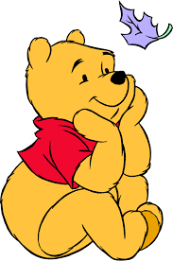
Winnie-the Pooh
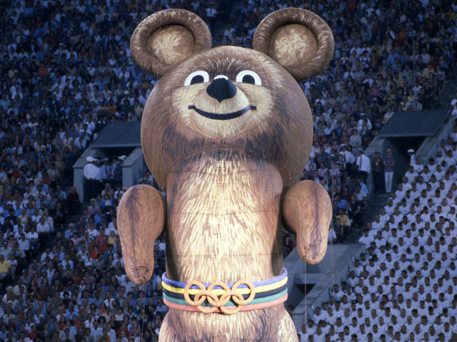
On August 21, 1921, A.A. Milne gave his son, Christopher Robin Milne, a teddy bear for his first birthday. In 1926 A. Milne wrote a book about the adventures of the teddy bear. The name of the teddy bear was Winnie-the Pooh.

Misha
Misha, also known as Mishka or The Olympic Mishka , is the name of the Russian Bear mascot of the 1980 Moscow Olympic Games (the XXII Summer Olympics). He was designed by children's books illustrator Victor Chizhikov
Songs about Teddy bear
Teddy bear, teddy bear,
Turn around.
Teddy bear, teddy bear,
Touch the ground.
Teddy bear, teddy bear,
Shine your shoes.
Teddy bear, teddy bear,
Skidoo.
Teddy bear, teddy bear,
Go upstairs.
Teddy bear, teddy bear,
Say your prayers.
Teddy bear, teddy bear,
Turn out the light.
Teddy bear, teddy bear,
Say good night
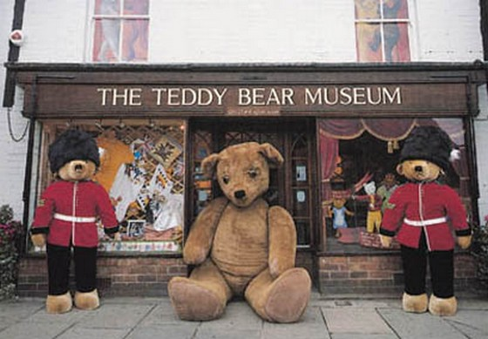
The world's first Teddy Bear Museum was opened in England in 1984 by Judy Sparrow.

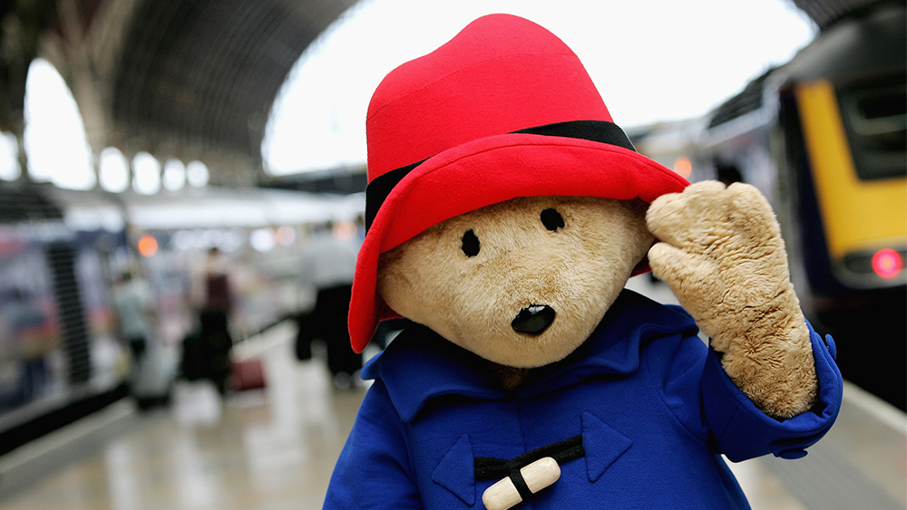
Paddington Bear.
One of the railway stations in London has his name. There is a statue of Paddington Bear at this station. Paddington Bear is a book hero. English writer Michael Bond writes books about Paddington Bear. He came to London from Peru with a suitcase and a table “Pleasе look after this Bear.” The Browns found the Bear at the Paddington railway station and now he lives happily in their family.
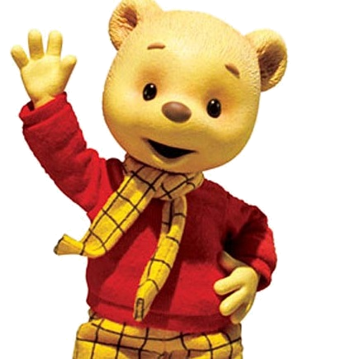
Rupert Bear

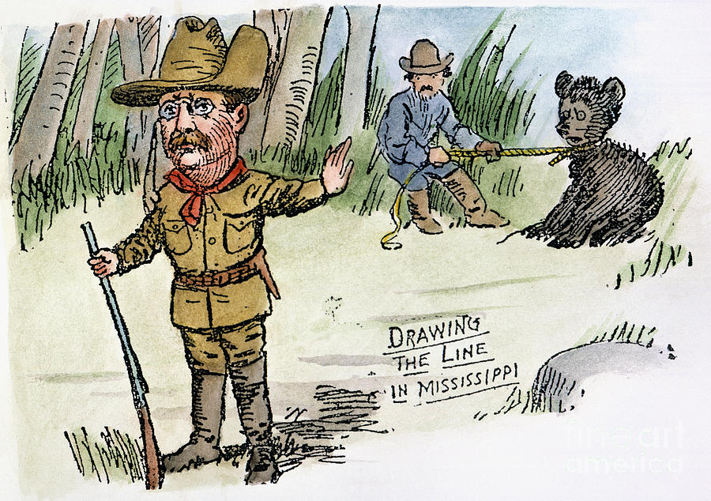
Rupert Bear is the hero of funny comics made by the English painter Mary Tourtel. He is a white bear who lives in Nutwood with his parents. Very often he wears a red jumper, tartan trousers and a stylish yellow scarf. Rupert is the favourite teddy bear of Paul McCartney from “The Beatles”. Paul McCartney made the song that made Rupert Bear famous.( Rupert and the Frog Song)
.

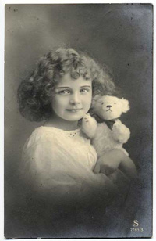
A seamstress lived in the little town. Her name was Margaret Shtrayf. She was ill, and she can not go. Therefore Margaret liked to make the soft toys very much. Her toys were very beautiful and children liked them. Margaret’s parents helped her to open the shop, which later became a family's business.
In 1902 year a first Teddy bear appeared. The bear made a lot of noise in the fair in Lepthing. It won a price and guests from the USA liked it very much. In 1902 year a first Teddy bear appeared. The bear made a lot of noise in the fair in Lepthing. It won a price and guests from the USA liked it very much.

Teddy bear got his name from the president of the USA Teodor Rusvelt. One day American president went to the district of Smids, state Missisippi. In the local forests there were many animals. Teodor Rusvelt decided to hunt. His assistants wanted to help the president and caught a little bear. Roosevelt was angry and released a bear.The caricature about a little bear and a kind president appeared next day . An owner of a toys shop,Morris Michtom, in New York saw this caricature . He made a soft bear and sent the toy to the president Roosevelt and asked if he could give him the name Teddy

The Famous Teddy Bears

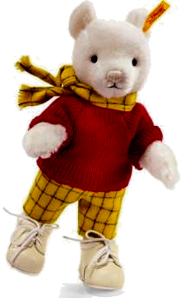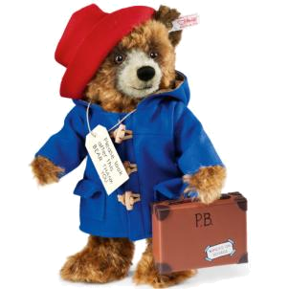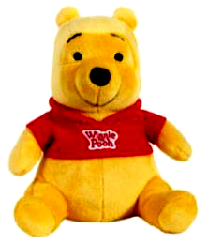
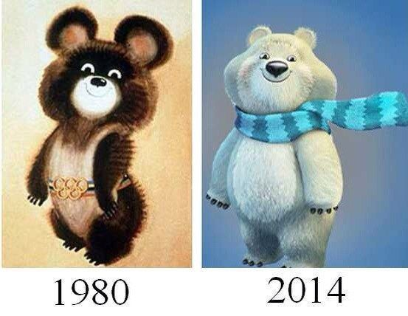


According to Wikipedia
«The teddy bear is a stuffed toy bear».

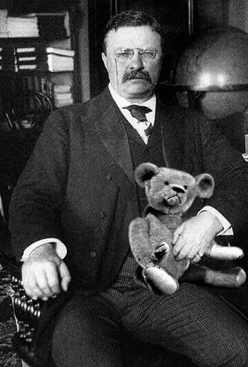
Made by Vitalina Ivanova
pupil of 5 form,
secondary school of Efremkino

