Районная научно-практическая конференция учащихся « Изучение языков – путь в культуру мира »
Направление : английский язык
Исследовательская работа на тему
«My native place is Arkhangel’skoe»
Березенкова Арина
МОБУ СОШ №2 с. Архангельское
8 класс
Научный руководитель:
Аллабердина А.С.
учитель английского языка
Архангельское -2015 г.

Contents
Introduction..............................................................................................................3
Chapter 1. Do you know about Arkhangel’skoe?.....................................................
Chapter 2. History of village Arkhangel’skoe………………………………………
Chapter 3. Our traditions…………………………………………………………….
Chapter 4.The sightseeings and the nature of my village……………………………
Conclusion…………………………………………………………………………
Literature...............................................................................................................25
Appendix

Introduction
There is no place like Home….
The theme of my research work is “My native place is Arkhangel’skoe”
Every person has a place where he was born, where he lives and works. It is our native place, our motherland.
Arkhangel’skoe is the village where I was born. The dearest people to me, my parents, my friends live here. We must know our home place, mustn’t we?
The village of Arkhangel’skoe is my home place. I live in it and love it greatly.
Why do I love my native village? This question is simple and difficult at the same time. I’ll try to answer it and express my point of view.
The aim of my research is studying the history of the village Arkhangel’skoe .
The object of research: the life of the village Arkhangel’skoe
The subject of research: the village Arkhangel’skoe.
My tasks of research are:
- to ask my classmates about the history of my village and my school;
- to visit the museum of secondary school №2;
- to find information about the history of the village , nationalities, famous people, traditions, sightseeings;
- to present my research work;
- to make a booklet “Welcome to Archangel’skoe!”
Methods of research are collecting and studying information, questioning of pupils from secondary school №2, the methods of mathematic processing of the results, interview.

Chapter 1. Do you know about Arkhangel’skoe?

In the course of our research paper we had to find out what our schoolmates know about history of village Arkhangel’skoe That’s why we questioned our schoolmates.
QUESTIONNAIRЕ (45 pupils from 8 – 11 forms were asked)
- When was Arkhangel’skoe founded?
- When was our school founded
- How many streets are there in Arkhangel’skoe?
- What attracts people in our village?
- Why do we love our village?
I`ve questioned the pupils of our school. Number of participants: 30 pupils from our school. The purpose of questioning was to know “Знают ли ученики свою малую родину”
The first question was “When was Arkhangel’skoe founded?” The 22% of my classmates know when was Arkhangel’skoe founded and 78 persons don’t know about it. Arkhangel’skoe was founded in 1753. We are proud of Arkhangel’skoe’s famous people.
The second question was “When was our school founded”? The 7% know that our school was founded in 1992 and 93% don’t know it. We have a school museum. It`s exhibitions tell us about history of our school, village, Heroes of the Great Patriotic war and teachers of our school.
The third question was “ How many streets are there in Arkhangel’skoe?”. The results : only two pupils answered that there are 65 streets, 28 pupils don’t know the right answer.
What attracts people in our village? For this question 14 participants answered – club of our village,11 participants said Jubilee Stadium. 5 pupils think that the most visited place is pond. And others said that there is no place in Arkhangel’skoe which attracts them.
So, Why do we love our village? 42% answered for its beauty. 32% love our Motherland for its unique places. Only 6% said - for its people: kind, hard-working, creative, who make our village beautiful. 20% people like Arkhangel’skoe, because it is a place where they were born.
After questioning I knew that there are many pupils who are not interested in history of our home place. It seemed to me very _______and________. I have an idea to collect and to show more information about my home place. I’d like to make up a project and present it in English. I think to know the history of our village is very important . [Appendix 1]

Chapter 2. History of village Arkhangel’skoe

I visited the museum and the library of secondary school №2 to study the history of the village, where I knew many useful information. [Appendix 1]
History of my village began 262 years ago. It is a village with an ancient history. It was founded in 1753. The first name of the village was Skimsky. There was a copper smelter. Later “Skimsky” renamed into Arkhangel’skoe in honor of St. Michael the Archangel . The life in those years was very difficult and poor.
Today Arkhangel’skoe is a modern village. There is gas, water, electricity in the houses. The most of the houses are big, new and nice. There are two secondary schools, a hospital, a house of culture, shops , a library in the village. One side of the village there is a mosque and on the other – a church. The villagers are proud of these magnificent building. In the village Arkhangelskoe there are 65 streets and alleys with a total length of about 69.7 km
Founded in 1753, Arkhangel’skoe at present has a population of 5990 people.
The population of Arkhangel’skoe consists of 15 nationalities: Russians and Latvians, Bashkirs and Tatars, and others.
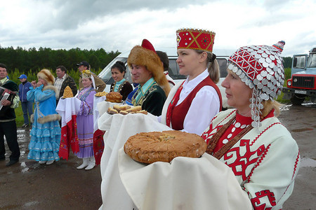
There are many interesting and famous people in our village: Veterans of the Great Patriotic War, excellent workers, talanted children.

Chapter 3. Our traditions

The villagers like to work and they like to rest interesting too. Every year national holidays, such as Maslenitsa, Easter, New Year , Sabantuy are hold in Arkhangel’skoe. We also celebrate Mother’s Day, Victory Day and others.
As for me my favourite holiday is Maslenitsa. It is a traditional holiday to say “goodbye” to winter and “hello” to spring. The concert is held in our village on this matter, the artists sing age-old songs, chastushkas and organize practical jokes. People take part in different competitions, ride horses and drink hot tea with pancakes not to be frozen. The pancakes are the main attribute of this festival because a pancake is a symbol of the sun. The festival always ends in burning of a big man of straw. The Lenten fast begins after Maslenitsa for orthodox believers.
On Forgiveness Sunday in the morning my whole family goes on a visit to my grandmother. She bakes the most delicious pancakes with different fillings. In the afternoon I meet with friends and we go to the central square and see street festivities. I consider that this festival brings people together and let them enjoy themselves and meet the spring together. [Appendix 3]

Chapter 4. The sightseeings and the nature of my village

There are a lot of interesting places to visit in our village:
- The monument to soldiers in the Great Patriotic War
- Secondary school №1 and Secondary school №2
- The mosque and The Church Of Michael The Archangel
- Jubilee Stadium
Monument to the soldiers in the Great Patriotic War
The Great Patriotic War was a dramatic page in the history of mankind, my country and my village. Many people of my village took part in it. They were awarded orders and medals. We remember the heroes’ names, who gave their lives for our Motherland. In school museum you can see some exhibits where documents and private things are displayed. By tradition we come to the memorial to commemorate the heroism of our people during the Great Patriotic War .
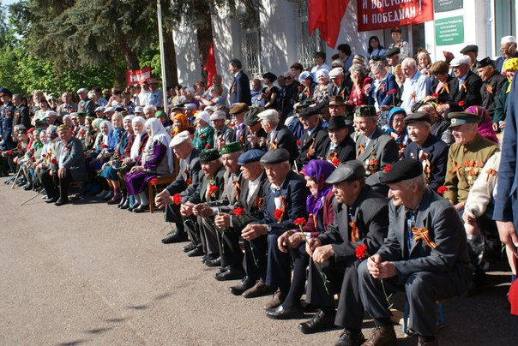
Secondary school №1 and Secondary school №2
Secondary school №1 was built in 1934. This year the school celebrated its 80th anniversary. During this time about 20000 pupils graduated from this school (172 physician,602 teachers,324 agricultural workers with higher education,14 candidates of different Sciences). Among them there were four Heroes of the Soviet Union: Pystigo I.I., Kiselev I.A., Saevich, T. A. and Ivan Antipin.
My school was built 50 years ago. It is quite big with sport ground behind it. Our school has many classrooms, which are light and spacious. Our school was built in 1992.
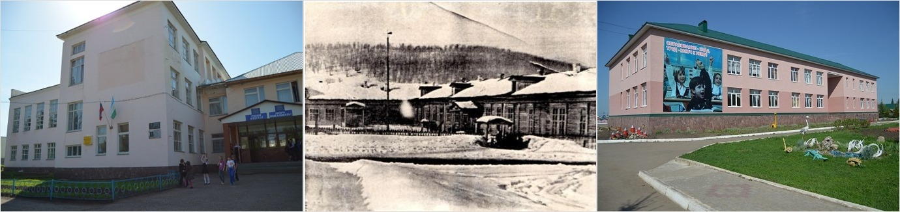
Our school also has a museum. It was opened in 1993. It`s exhibitions tell us about history of our school, village, Heroes of the Great Patriotic war and teachers of our school.
In museum you also can find an Interesting material about Kiselev M. A. who was the war veteran and the veteran of pedagogical work. His daughter, our English teacher Abramchuk I. M., gave father’s photographs, letters, awards to the Museum .
But when I think about my school I don’t think about its walls and desks; it is my teachers and classmates who will be always with me.
Sport is very popular among people in our village . Jubilee Stadium was opened in 2013. A lot of different competitions are held there; a great number of participants take part in them. In winter we usually go to watch or support our favourite hockey team “Al’tair”. All these events play an important role in our physical development. [Appendix 4]
It goes without saying Arkhangel’skoe is one of the most wonderful places in the world. It is situated on the bank of the river Skimka.
There is one more important aspect that I love my village. I mean our marvelous nature. It’s majestic with varied landscapes: the river Skimka, the forests surrounding the village, fields and meadows. How beautiful our glorious sunrises and golden sunsets are!
There are many rhymes about the nature, the people of my village. The authors say how they love their home place, how they respect people for their everyday work. [Appendix 5]
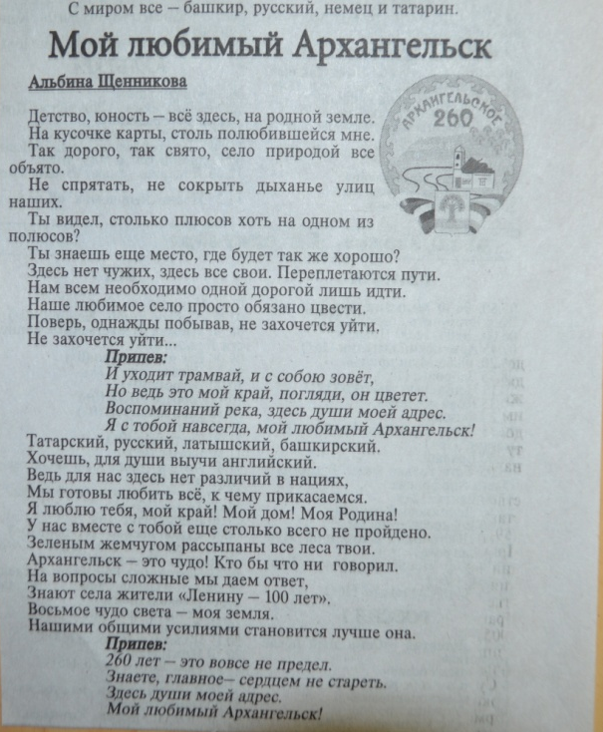
Welcome to our village Arkhangel’skoe. We’ll be glad to meet you here.
Conclusion

I have achieved the aim of my work. I’ve made the booklet “Welcome to our village Arkhangel’skoe!”First of all I collected the information about my village . I visited the museum and the library of secondary school №2 . I worked with historical documents, interviewed Natal’yu Vital’evna Yanko- the teacher of History of Bashkortostan and Irina Viktorovna Stapenko – the librarian of secondary school №2 , read letters and diaries.
During my work on the project I have improved my English, have learned
how to make slides and have known how to do the project.
I hope English written texts can be used as cards at the lessons.
I think that my work is interesting and fascinating not only for me but for some students who wants to know about the history of our home place. It is not the end of my work I continue my work.

Literature
- Official website of Arkhangelsky District.
- Справочник «Архангельское сердцу милый край»
- Газета «Архангельский вестник» 13 апреля, 2002 года
- Газета «Архангельский вестник» 15 мая, 2002 года
- Газета «Архангельский вестник» 23 марта, 2002 года
- Газета «Архангельский вестник» 6 января, 2001 года
- Газета «Архангельский вестник» спецвыпуск ,17 октября, 2008 года

Appendix 2. In the museum and the library of secondary school №2
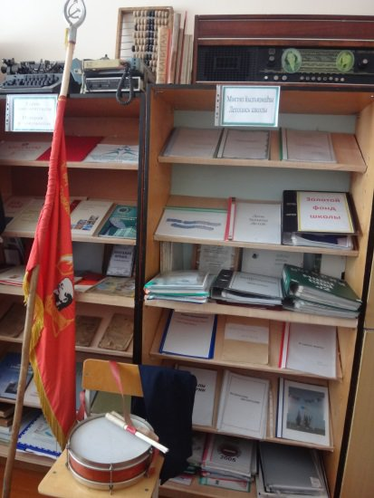
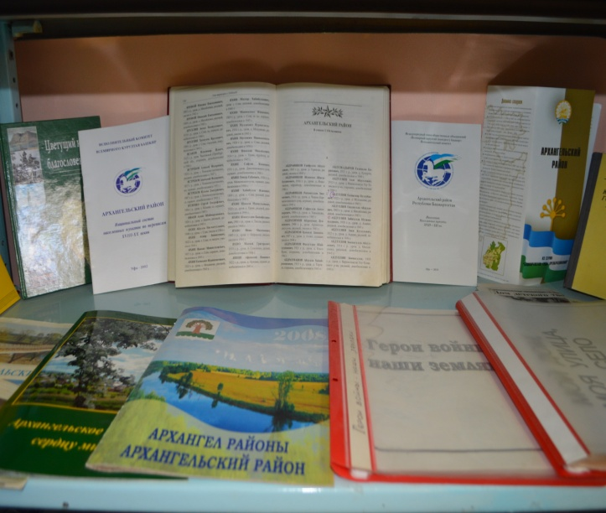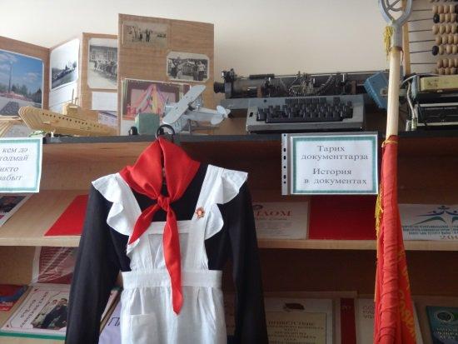

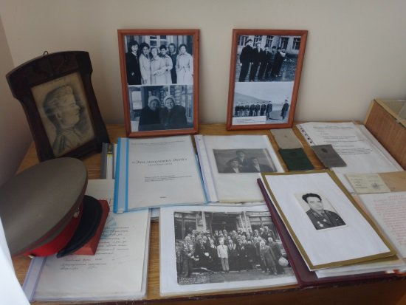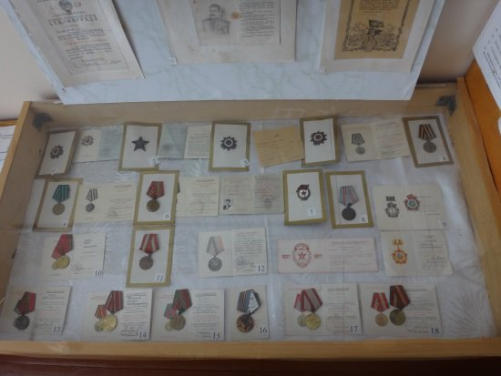
Appendix 3. Maslenitsa
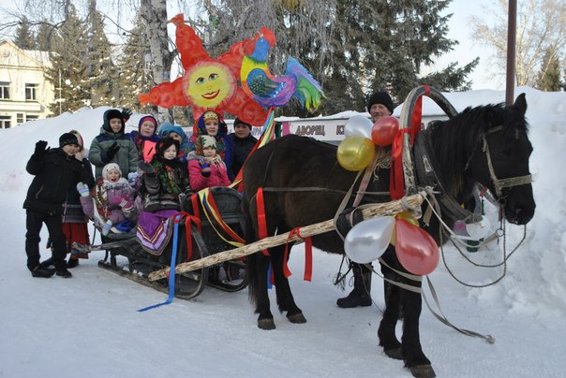
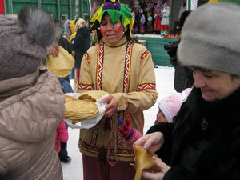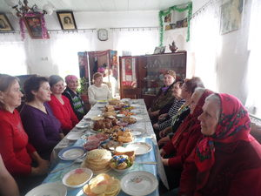
Appendix 4. Our favorite hockey team “Al’tair”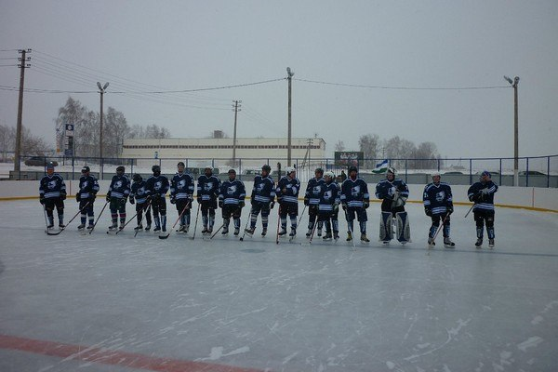 Appendix 5.
